SIMATS ENGINEERING (SAVEETHA SCHOOL OF ENGINEERING) Department of Computer Science and Engineering
ASSESSMENT TOOL 2 – SCENARIO BASED ASSESSMENT
Course Code: | CSA06 | Course Title: | Design and Analysis of Algorithms
CO Assessed: | CO2 – Manipulation (BL1, BL2, BL3) | Assessment: | Assessment Tool 2 – Scenario Based Assessment
Weightage: | 20% of CIA | Total Marks: | 100
CO2 Statement: | Apply Brute Force technique to solve sorting, searching, Closest-Pair and Convex-Hull problems (BL1, BL2, BL3)
Student Name: | P Sanjeev | Reg. No.: | 192324231
Section / Batch: | AI&DS 2023 | Date:

Instructions to Students
• Answer the following question. Total Marks: 100.
• Carefully analyze the given scenario and identify the computational problem involved.
• Apply appropriate Brute Force techniques for sorting, searching, Closest-Pair, and Convex-Hull problems wherever applicable.
• Clearly justify the chosen solution approach with proper reasoning and analytical interpretation. • Demonstrate decision-making skills by comparing possible solutions and selecting the most suitable approach. • Use diagrams, stepwise illustrations, or algorithmic representations wherever necessary.
• Maintain clarity, logical organization, and proper technical presentation throughout the answers.

Question Type | Focus Area | Questions
Scenario Based  Assessment | Analyze real-world scenarios and apply Brute Force techniques for sorting, searching, Closest-Pair, and Convex-Hull problems | Q1

SECTION A – SCENARIO BASED ASSESSMENT
Code of Conduct
I P Sanjeev/192324231 (Name / Reg No) certify that this submission is my original work and that I have adhered to the guidelines specified for this assessment. I understand that any violation of academic integrity rules will result in disciplinary action.
Signature of the Student: _________________________

RUBRICS FOR CALCULATION
Criteria | Wt. | Level 4 – Exemplary | Level 3 –  Proficient | Level 2 –  Developing | Level 1 –  Beginning
Problem  Understanding & Context  Analysis | 25% | Thoroughly  understands the  scenario with accurate interpretation of all  requirements | Clearly  understands the scenario with  minor gaps | Basic  understanding; some aspects of the scenario  unclear | Poor  understanding or misinterpretation of the scenario
Application of  Concepts | 30% | Applies appropriate concepts effectively to solve complex real  world problems | Applies relevant concepts  correctly with  minor errors | Applies basic  concepts but  with limited  accuracy | Fails to apply  appropriate  concepts
Analytical &  Decision  Making Skills | 20% | Demonstrates strong analysis and selects optimal solutions with justification | Good analysis  with reasonable solutions | Limited  analysis;  solutions lack  justification | Poor or no  analysis; incorrect decisions
Solution Design & Approach | 15% | Well-structured,  innovative, and  feasible solution  approach | Logical and  structured  solution with  minor gaps | Basic solution  with limited  structure or  feasibility | Unclear or  incorrect solution approach
Clarity,  Justification & Presentation | 10% | Clear, well-justified explanation with strong reasoning | Clear explanation with some  justification | Limited clarity  and weak  justification | Poorly explained with no  justification

Marks Evaluation:
Criteria | Wt. | Level 4 –  Exemplary | Level 3 –  Proficient | Level 2 –  Developing | Level 1 –  Beginning
Problem Understanding & Context Analysis | 25%
Application of Concepts | 30%
Analytical & Decision-Making Skills | 20%
Solution Design & Approach | 15%
Clarity, Justification & Presentation | 10%
Total Marks (100):

Faculty In-charge | Course Coordinator | Head of Department
Name: | Name: | Name:
Signature: _______________ | Signature: _______________ | Signature: _______________
Date: ___________________ | Date: ___________________ | Date: ___________________

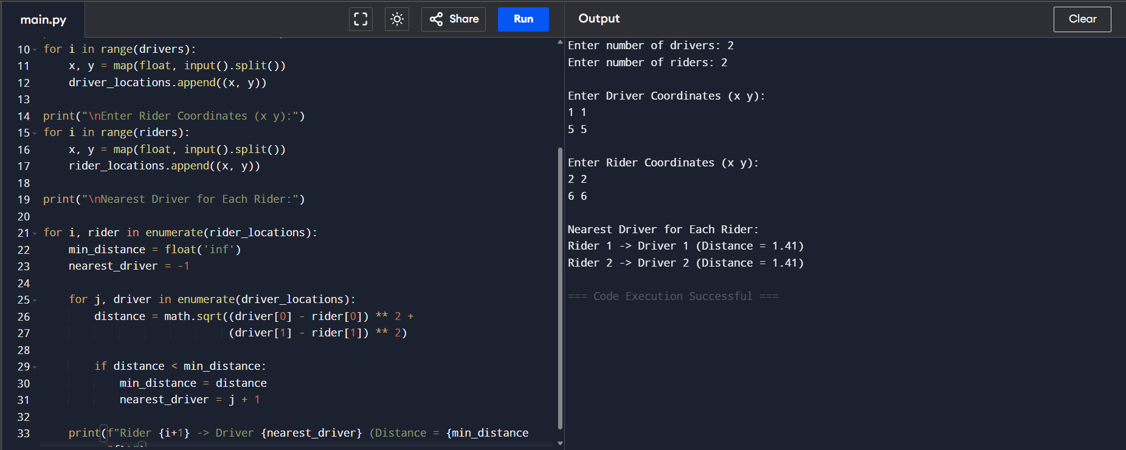
1st Question:
2nd Question:

